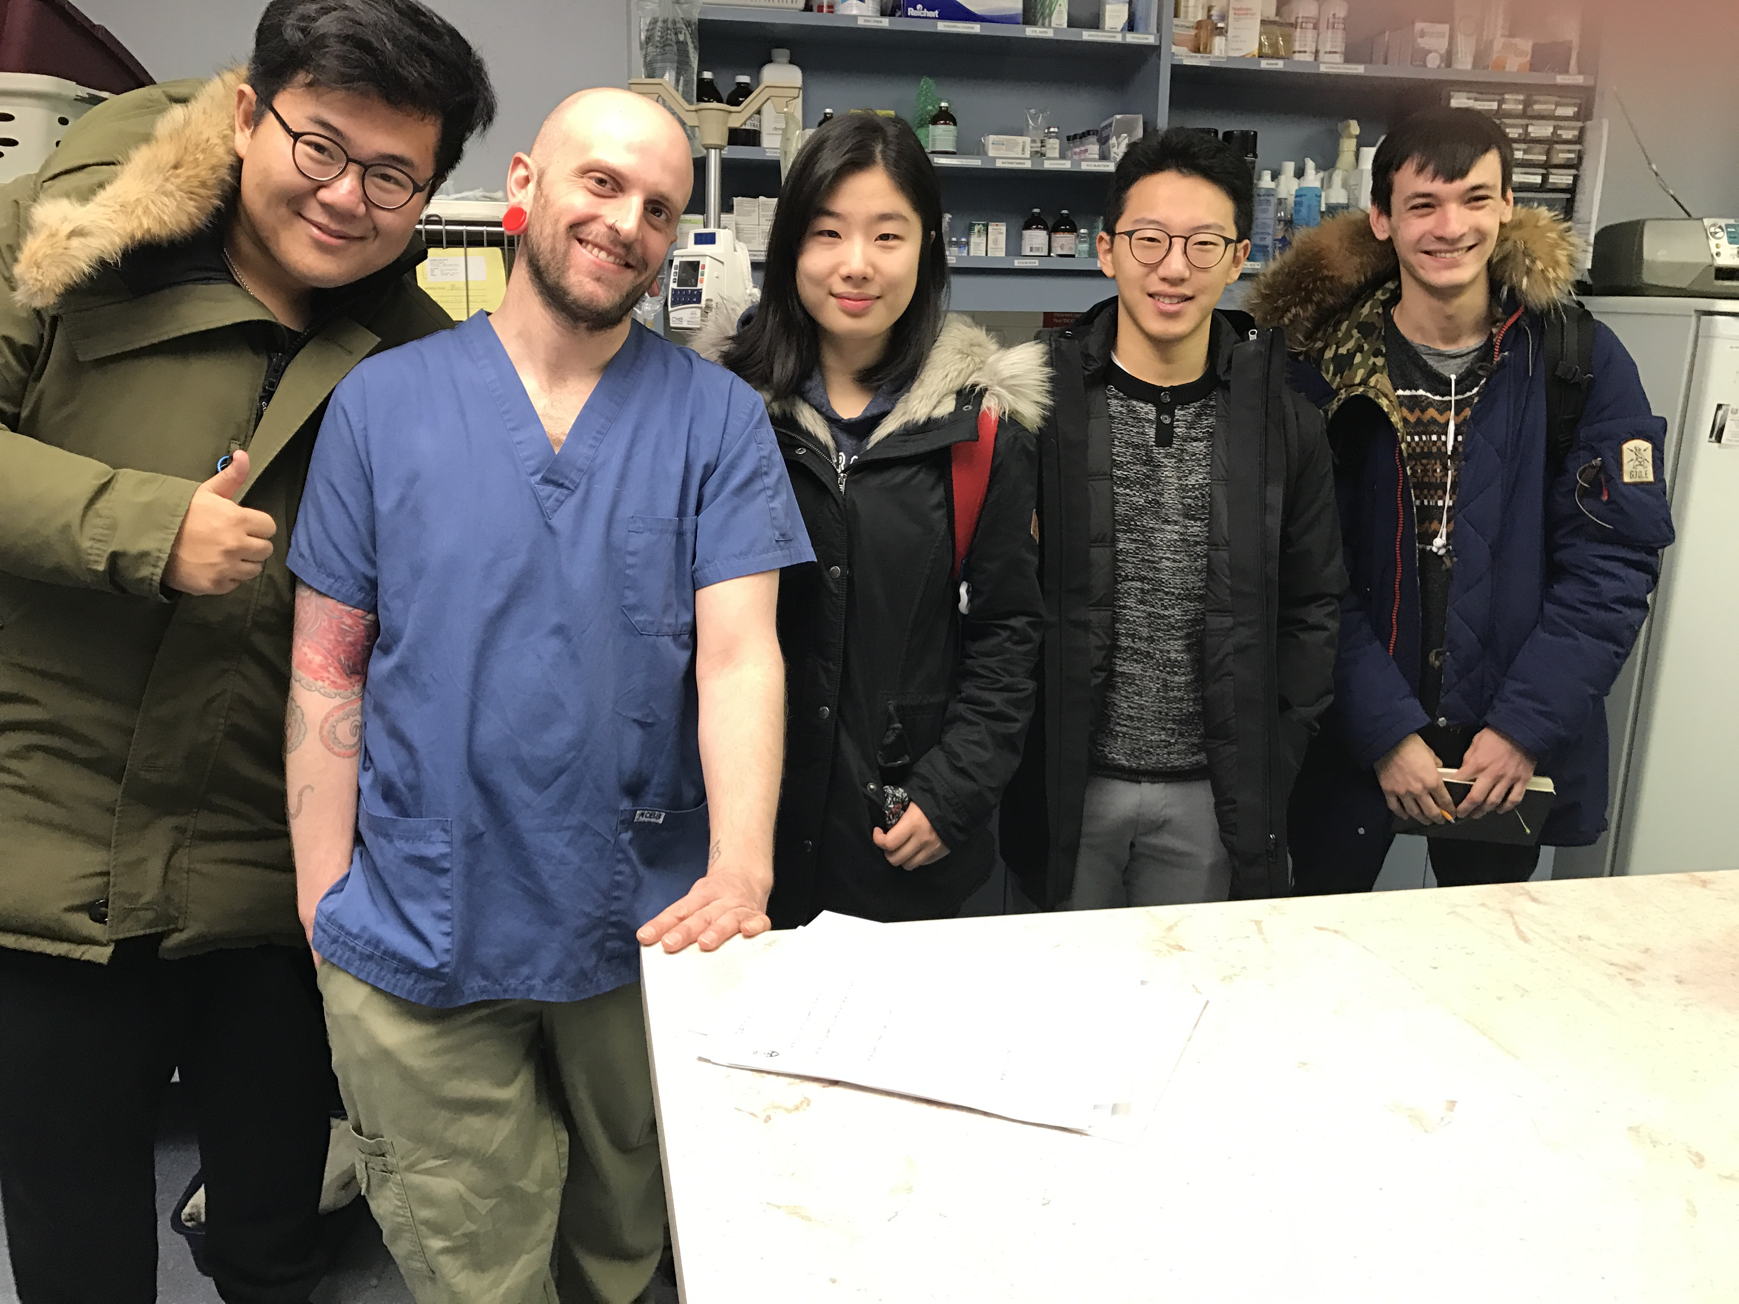

FIELD NOTES

Yuxuan Chen

1002942587

**Introduction:**

The organization we visited is downtown Toronto Animal hospital. This organization offers a variety of animal veterinary services as well as monitored pet boarding.[1]. According to the Canadian Pet Market Outlook in 2014, 57 percent of Canadian Households own pets [2], hence I believe there will be a lot of opportunities in animal health care. Based on my personal experience of owning two dogs for years, I am particularly interested in the area that is related to animals. Personal interest in animals allows me to gain a better understanding in this field. We choose downtown Toronto animal hospital due to its vicinity to university, which allows us to interact with stakeholders more frequently and more conveniently.

**Summary:**

The hospital is two stories high. The front desk is located at main floor which mostly deal with phone calls from customers. They also sell dogs/cats food, and animal accessories like toys and treats in the waiting area [3]. The pharmacy is behind the front desk where staffs organize and sort all the medications and put them on shelves. The top shelf is more than 2 meters high, which is hard to reach for people of average height. [4]

The hospital includes boarding facilities on the second floor that allows pet owners to leave their pets in the hospital while they are away. Dogs and cats are separated into two different rooms. It can supports maximum of 8 small breed dogs, three large breed dogs, and about 10 cats. Each pet has it's own crate that has one clipboard hanging in front of it.[4]. It include all the relevant information about the pets, including breed, age, feeding schedule, allergies, and contact info on several pieces papers. Those papers are of different sizes, and they are not in order. The odor is pretty strong on the second floor, and dogs were barking really loud.

There are two surgery rooms on the second floor as well. One is used for ordinary procedures like giving a shot, nails trimming, grooming. And another one is for major surgery that involves more complicated procedures. It has a x-ray machine and all the other surgery apparatus. [7]

**Evaluation:**

One thing I learned from personal interaction with stakeholders is detailed procedures of how they operate the hospital on a daily basis, and some of the most common cases they are dealing every day. Those kind of information can not be found on their website. Walking around in the hospital in person allows me to pick up some other information that cant be obtained from plain text.[9]

I have learned from the veterinarian assistant in the animal hospital, Greg, that the most common illness they see in pets are vomiting and diarrhea. Those are usually caused by ingesting wrong food. And one of the biggest difficulties they encounter during daily work is the strong odor from animals and the constant noise. The excessive barking is common in hospital because pets get scared when they are away from their familiar environment and away from their owners. This can be confirmed by articles online [8]. The best way to distress the pets is using the pheromone spray[11] or forcing them to wear thunder shirt.[6]

Another difficulty for staff is that different pets have different feeding schedules and diet requirements, which makes it very hard for them to follow and keep track of.

One opportunity that I believe is worth pursuing is to redesign the crates to provide solutions to multiple issues at the same time.

I can design a crates that can store a large amount of food but only give certain amount food to pet at a certain time, and the user can set the quantity and time using the tablet integrated in this design. This relieve the staffs from the redundant feeding procedures. Additionally, I would like to include the nozzle inside of the crate that can spray the pheromone to reduce the anxiety of pets. Including a digital system allows the staff to store information about pets electronically, without worrying about loosing the only paper copy.

From the observation, the hospital has a relatively small capacity for big breed dogs. Greg explained to us that there are more small breeds dogs in downtown area, so they have more spots available for small breed dogs. So the crate would be designed for small breed dogs.

**Next step:**

Next step is to prove the legitimacy of this opportunity by doing substantiate amount of research to back up the technology. First of all, I need to find out if there is any existing solution that can address the proposed problems, and if there is any solution I can find out if I can improve that design to make the existing solution better. I would do a lot of research to find out the potential side effect of pheromone, or any alternative option available to reduce anxiety, and the feasibility of the auto feeding mechanism. I would keep in touch with the animal hospital to see if they are interested in my idea, and I would email more hospital to see if this design can be applied to broader areas.

**REFERENCE**

[1]Downtown Animal hospital – Tronto Veterinarians

<http://www.downtownanimalhospital.ca/site/hospital-services/>

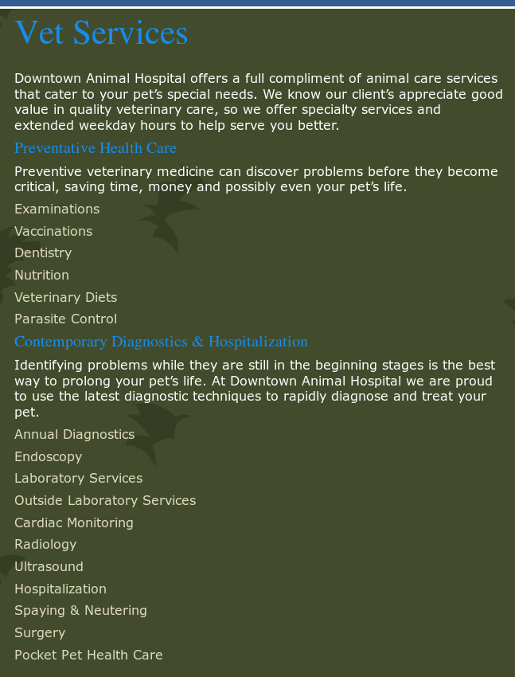

[2] static of pets ownership.

<http://www1.agric.gov.ab.ca/$department/deptdocs.nsf/all/sis14914>



[3] [4]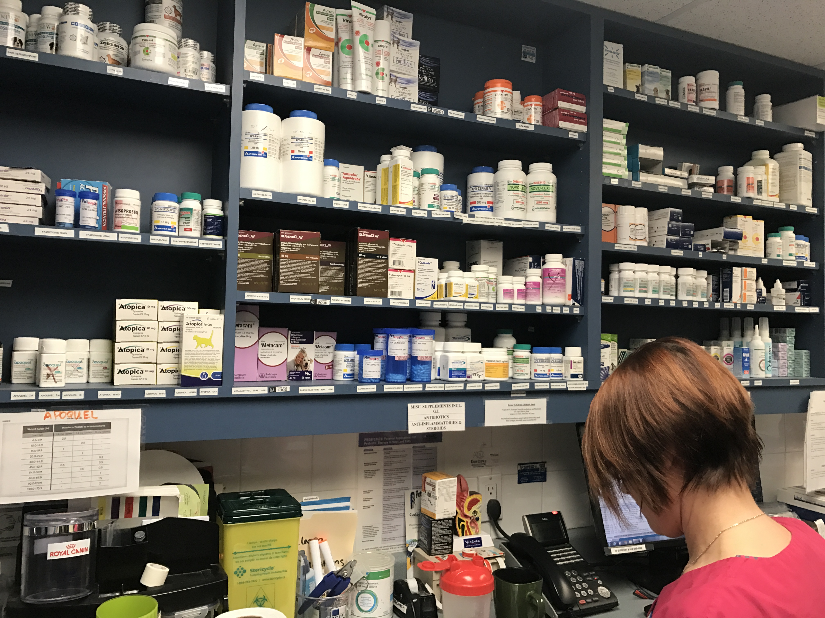

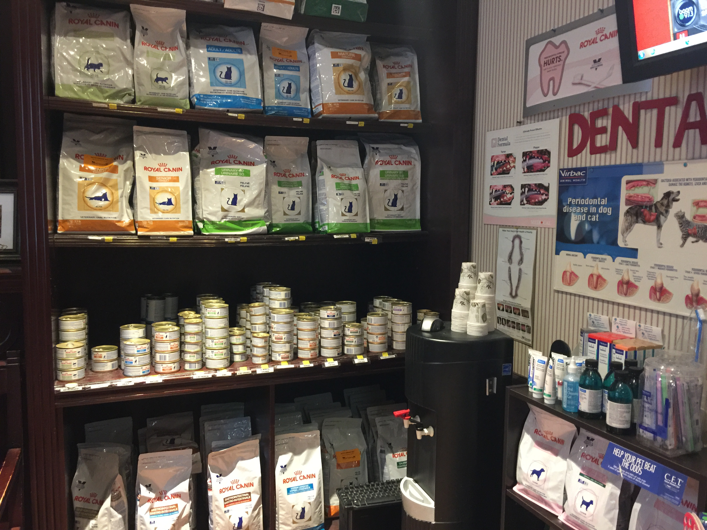

[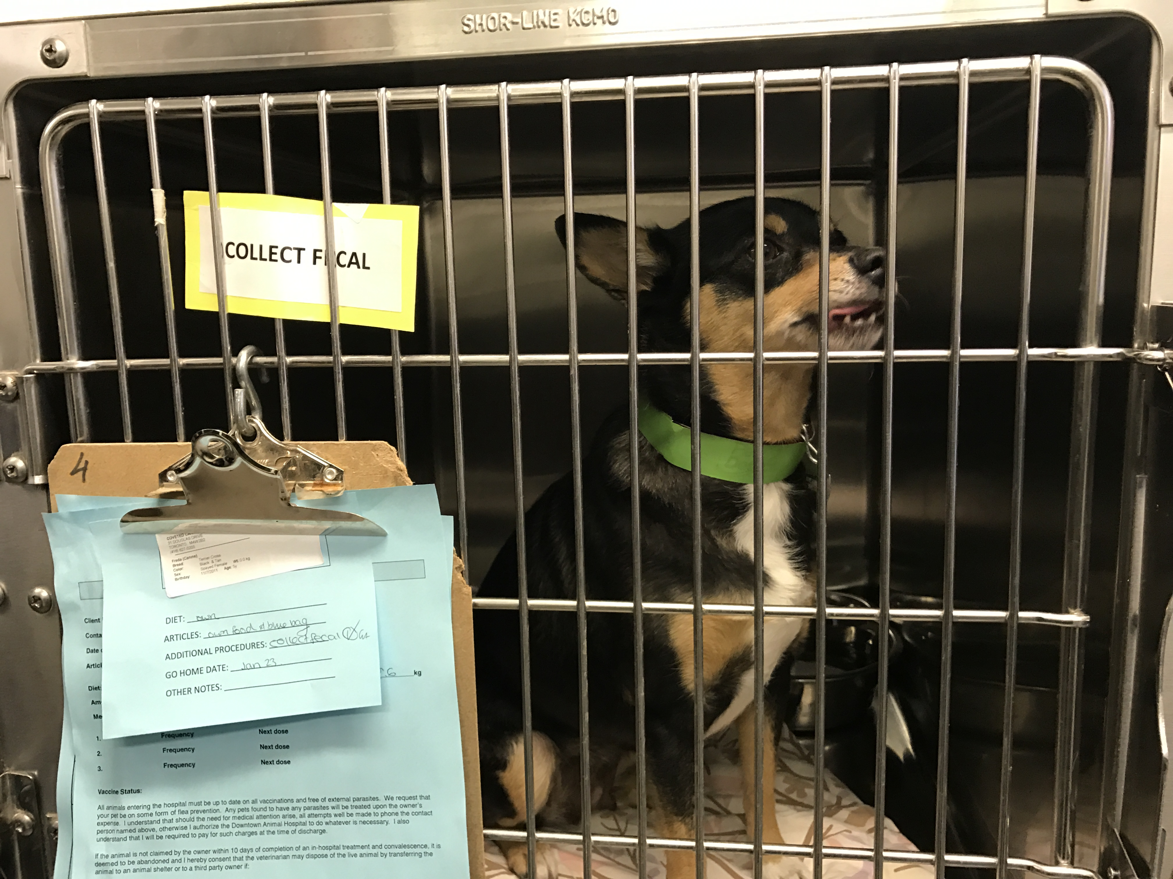5]

[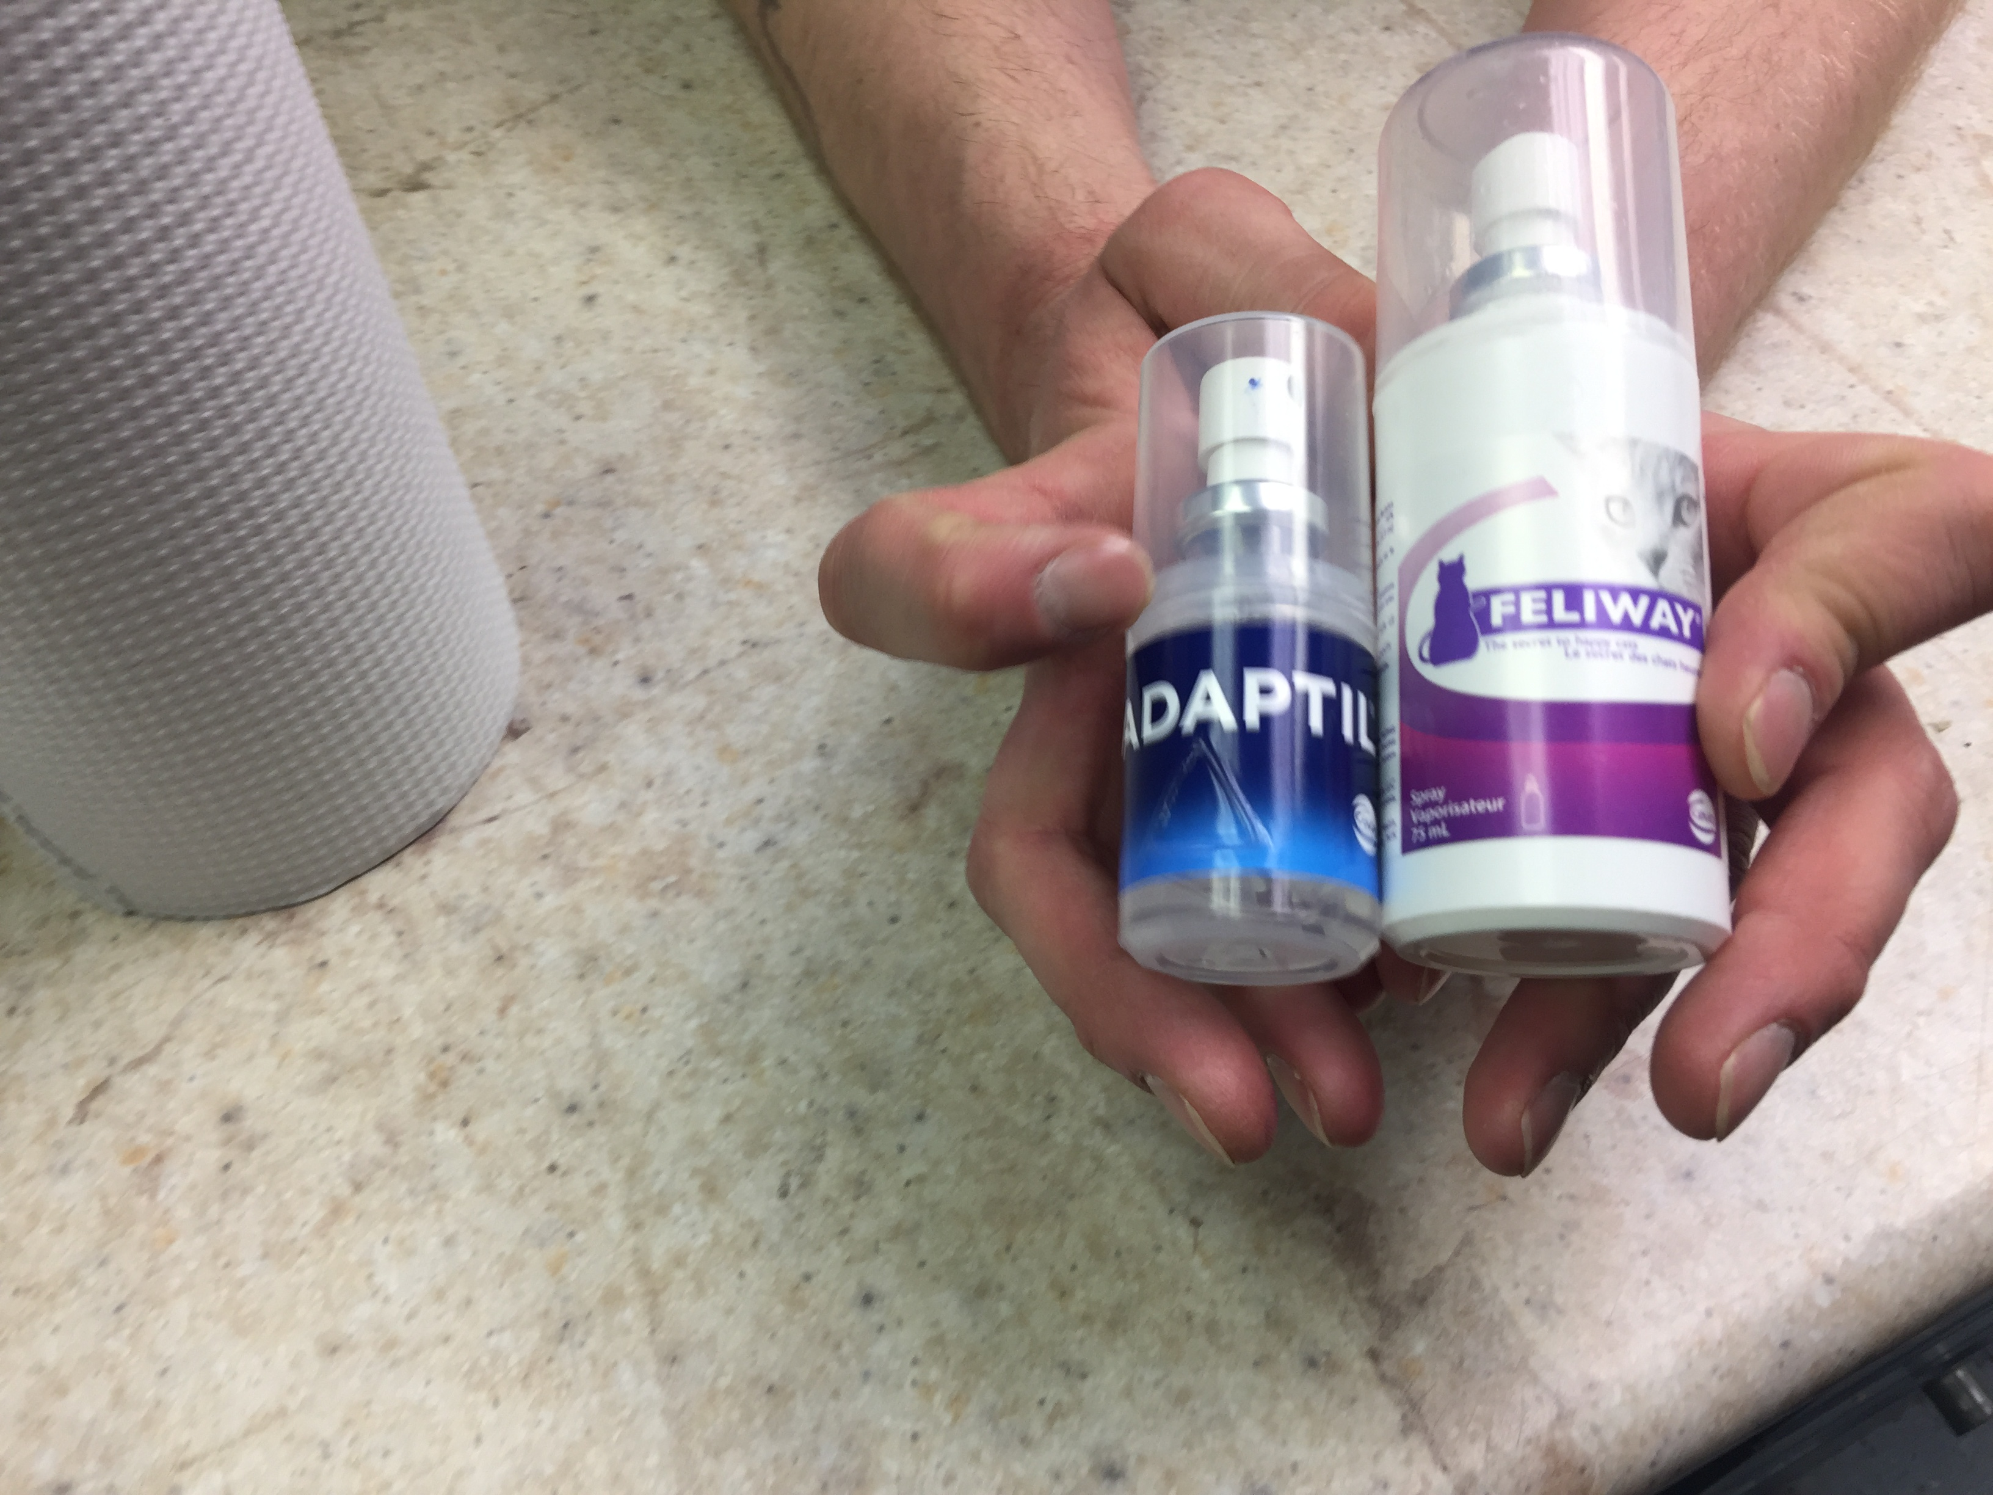6]

[7]

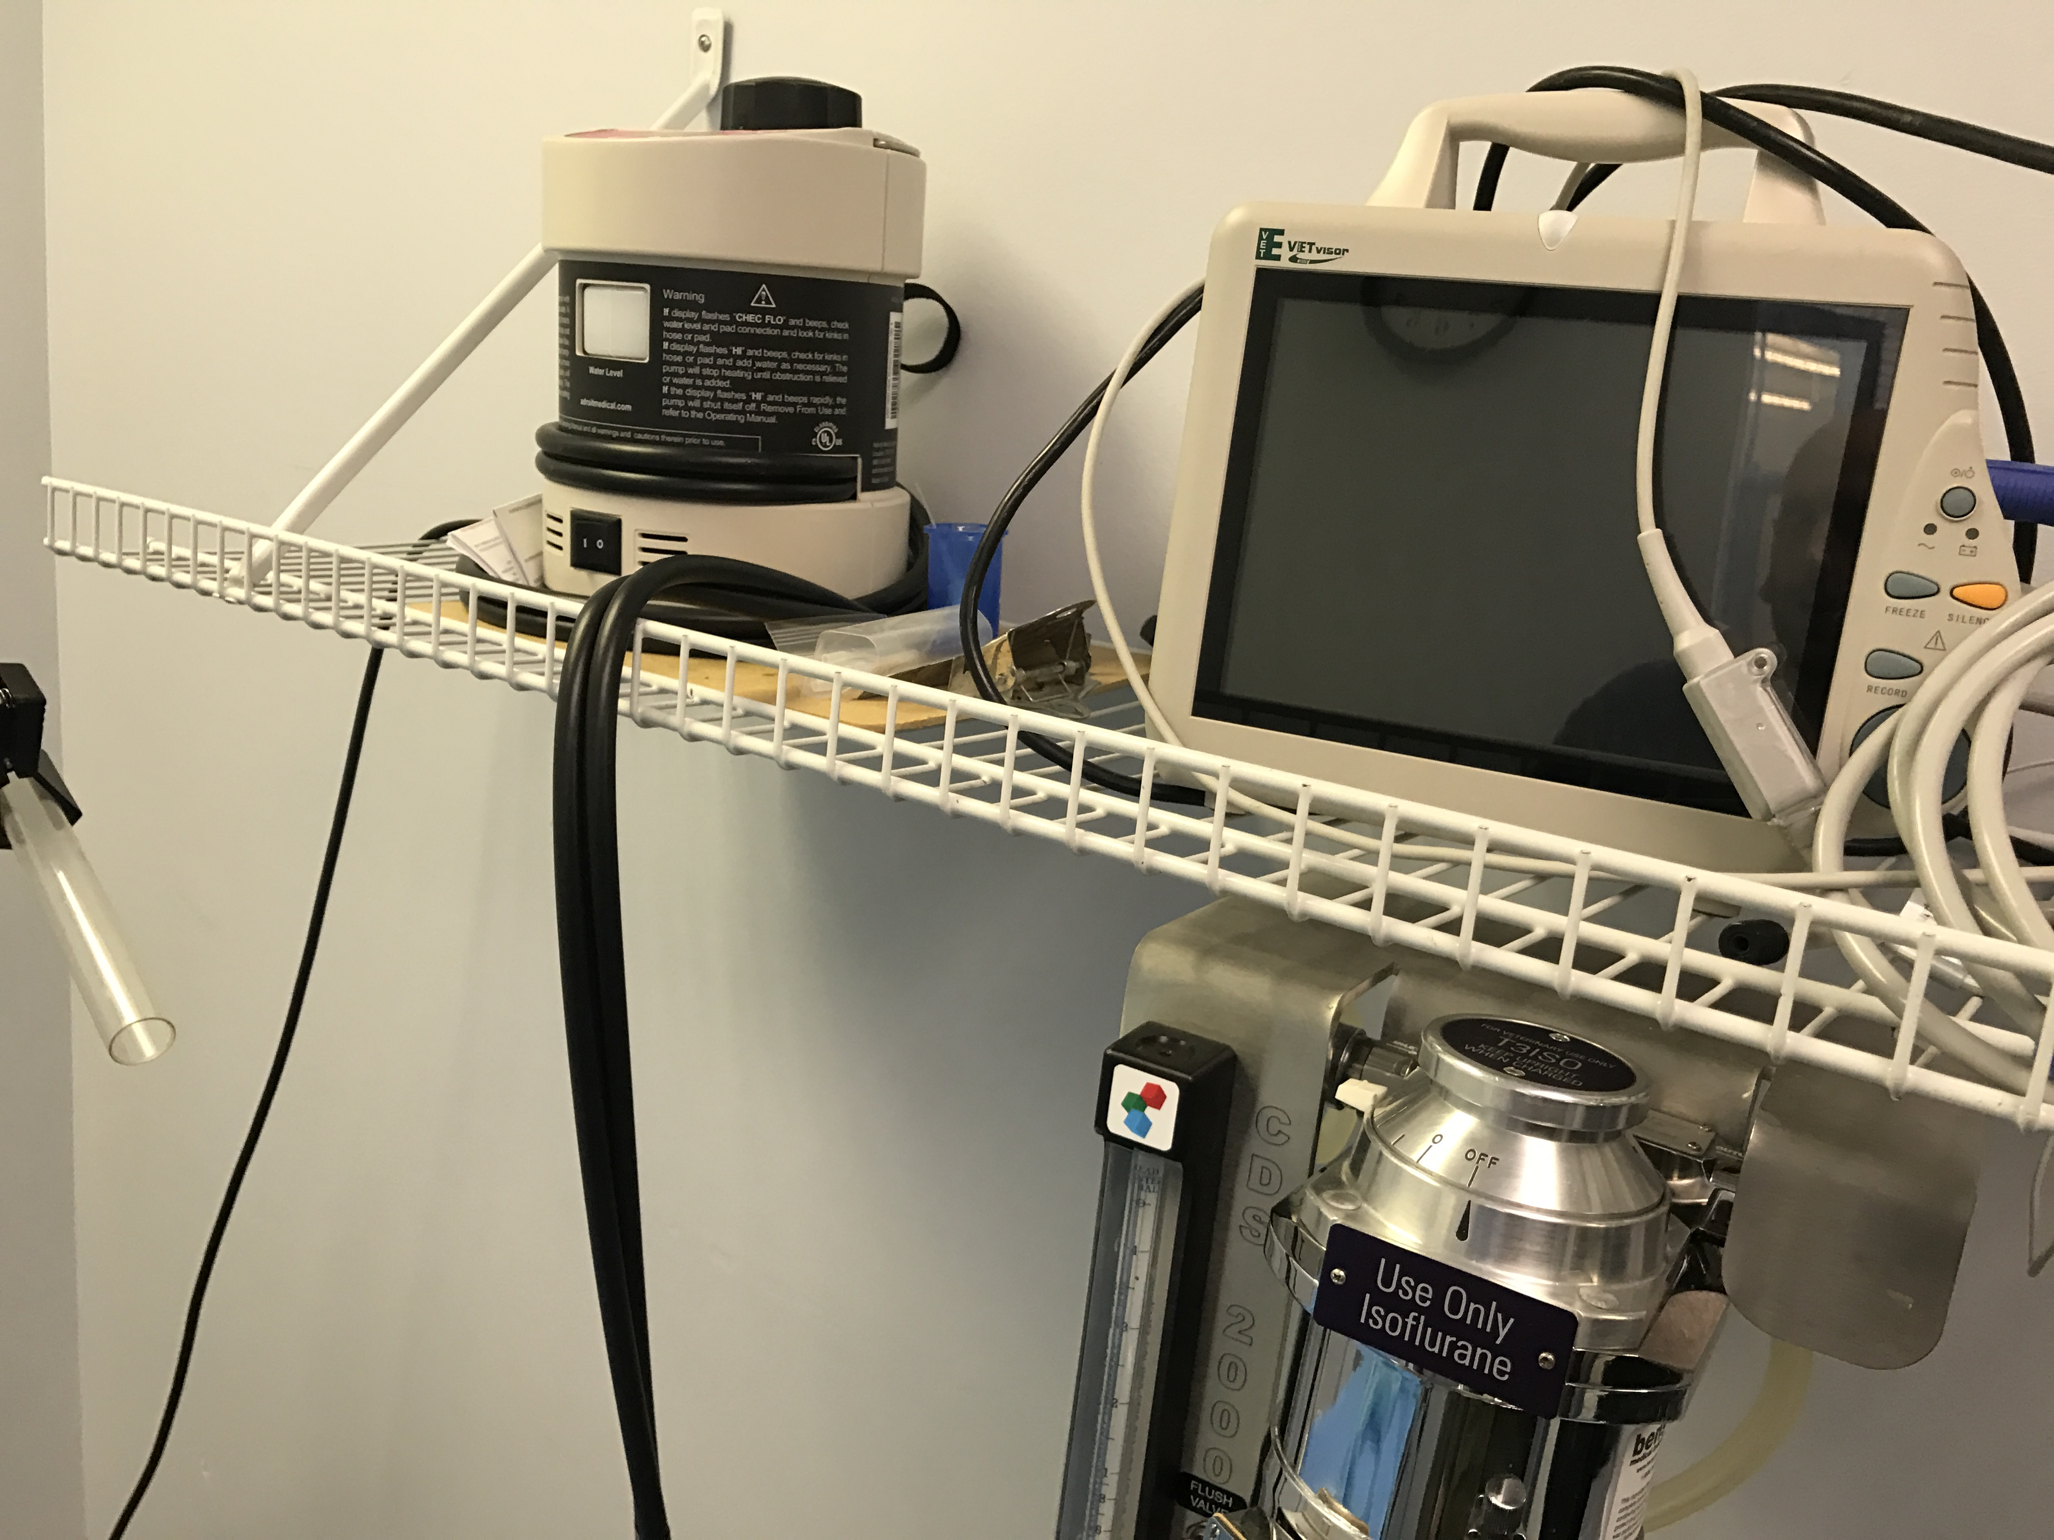

[8]

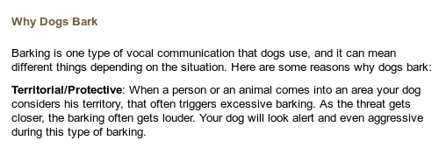

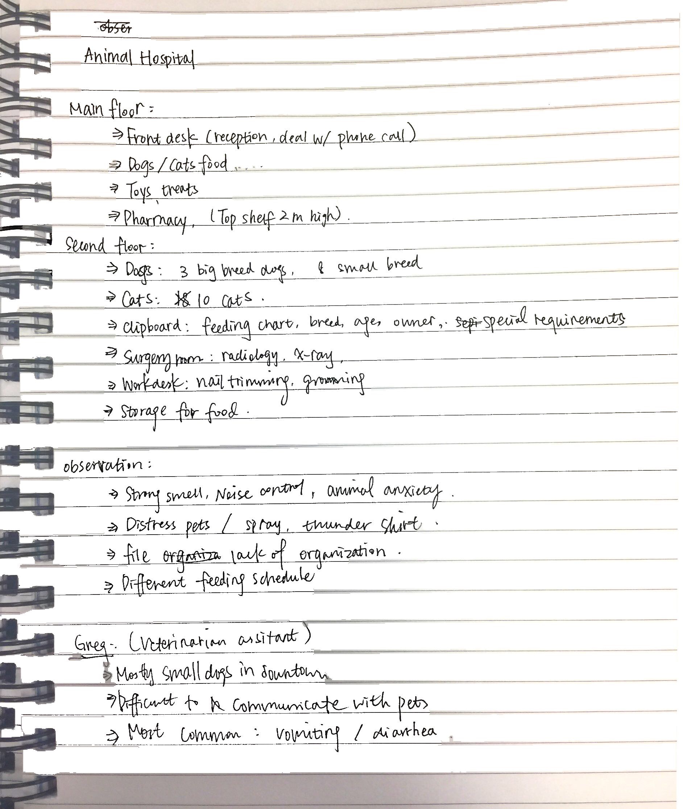

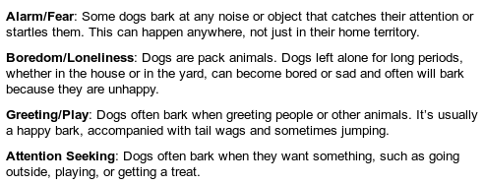

[9]

[10]

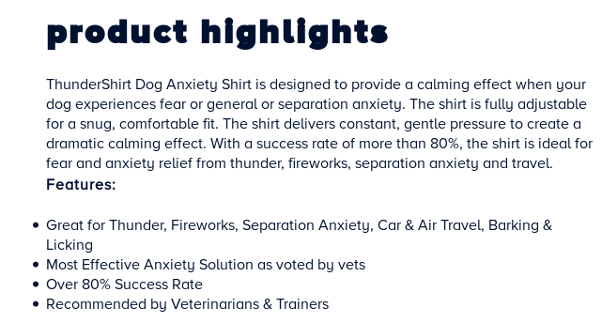

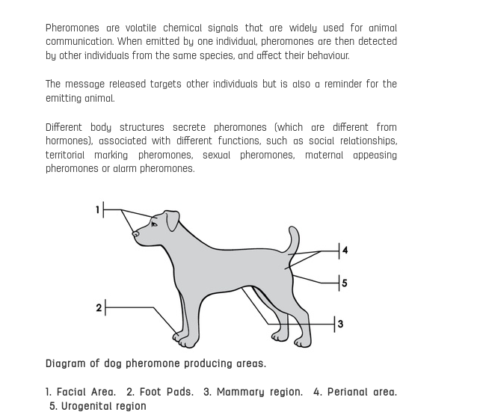

[11]